SIMATS ENGINEERING
ASSESSMENT TOOL 1

COURSE NAME: Artificial Intelligence COURSE CODE: CSA17

COURSE OUTCOME COVERED

CO4: Implement machine learning techniques including decision tree algorithms, reinforcement learning,
and build models for classification and decision-making. (BL3)

Assessment Tool Weightage: 40%

Duration : 45 Minutes
QUESTIONS: 2 Total Marks:20

Annexure A

INTEGRATED EXPERIMENTS

Code of Conduct:

I S.SHAMAH ALI FATHIMA(192573002) (Name / Reg No) certify that this submission is my original work and that I have adhered to the guidelines specified for this assessment.
I understand that any violation of academic integrity rules will result in disciplinary action.

Signature of the student:
Shamah

Annexure A

INTEGRATED EXPERIMENTS

Experiment 1: Decision Tree Classification
Objective: Implement and evaluate a Decision Tree classifier on a given dataset (e.g., Iris / Play-Tennis) using Python / any ML library.

(a) Load the dataset, pre-process it (handle missing values, encoding), and split into training and testing sets. Display the first 5 rows and data types.
(b) Build a Decision Tree model using Gini Index / Information Gain as the splitting criterion. Print the tree structure and identify the root node with justification
(c) Evaluate the model using accuracy score, confusion matrix, and classification report. Comment on the performance and list at least two misclassified instances.

Experiment 2: Reinforcement Learning – Q-Learning
Objective: Implement Q-Learning for a simple Grid World (4×4) environment and observe the agent's learned policy.

(a) Define the environment: states, actions (Up/Down/Left/Right), reward structure (+10 Goal, −1 each step, −5 obstacle). Initialize the Q-table with zeros and state the hyperparameters (α, γ, ε).
(b) Run the Q-Learning algorithm for at least 100 episodes. Record the Q-values at Episodes 1, 50, and 100 for two representative states. Show how the Q-table evolves.
(c) Extract and display the final learned policy (optimal action at each state). Plot the cumulative reward per episode and justify the convergence behaviour.

RUBRICS FOR CALCULATION:
Criteria | Weightage | Level 4 – Exemplary | Level 3 – Proficient | Level 2 – Developing | Level 1 – Beginning
Understanding of Concepts | 25 | Demonstrates thorough understanding and effectively integrates multiple concepts/technologies | Good understanding with proper integration of most concepts | Basic understanding; limited or partial integration | Poor understanding; unable to integrate concepts
Experimental Design | 30 | Well-planned, systematic implementation with optimal solution | Correct implementation with minor issues | Basic implementation with errors or inefficiencies | Incorrect or incomplete implementation
Use of Tools | 20 | Effective and advanced use of tools/technologies with proper configuration | Appropriate use of tools with correct execution | Limited or inconsistent use of tools | Incorrect or minimal use of tools
Analysis of Results | 15 | Insightful analysis with accurate interpretation and validation of results | Good analysis with reasonable interpretation | Basic analysis with limited insights | Poor or incorrect analysis of results
Documentation | 10 | Clear, well-structured documentation with diagrams, code, and results | Organized documentation with necessary details | Basic documentation with missing details | Poor or incomplete documentation

EXPERIMENT 1: DECISION TREE CLASSIFICATION

Objective:
To implement and evaluate a Decision Tree classifier on the Iris dataset using Python and Scikit-learn.

(a) Load, Pre-process and Split the Dataset:
Aim:

To load the Iris dataset, check the data types, handle missing values, and divide the dataset into training and testing sets.

Program:
from sklearn.datasets import load_iris
from sklearn.model_selection import train_test_split
import pandas as pd

# Load dataset
iris = load_iris()

# Create DataFrame
df = pd.DataFrame(iris.data, columns=iris.feature_names)
df['species'] = iris.target

# Display first 5 rows
print("First 5 rows:")
print(df.head())

# Display data types
print("\nData Types:")
print(df.dtypes)

# Check missing values
print("\nMissing Values:")
print(df.isnull().sum())

# Features and target
X = df[iris.feature_names]
y = df['species']

# Split into training and testing data
X_train, X_test, y_train, y_test = train_test_split(
X, y, test_size=0.2, random_state=42, stratify=y
)

print("\nTraining samples:", len(X_train))
print("Testing samples:", len(X_test))

Output:

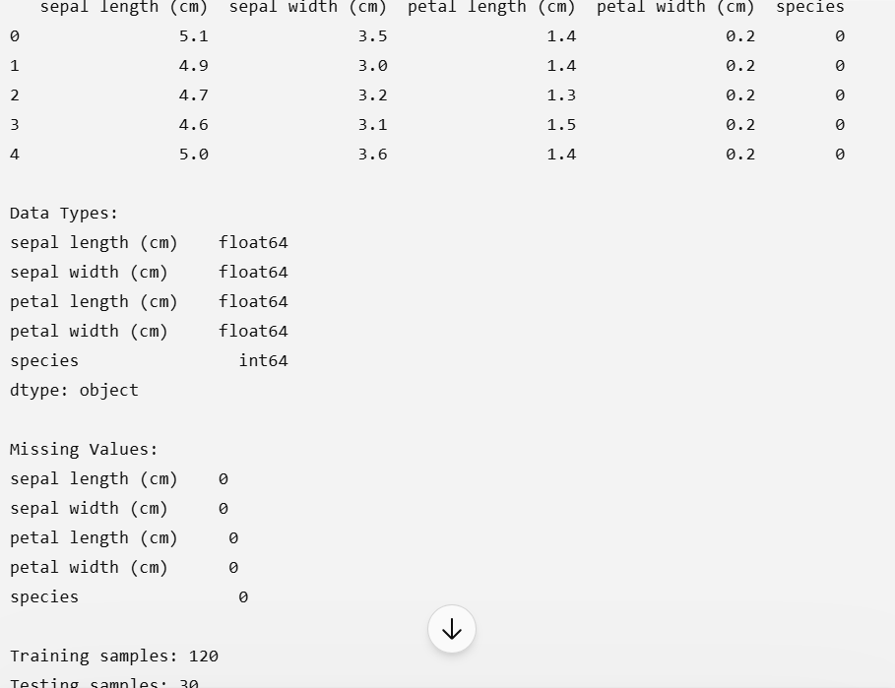

(b) Build Decision Tree:
Aim:

To build a Decision Tree classifier using the Gini Index and identify the root node.
Program:

from sklearn.datasets import load_iris
from sklearn.model_selection import train_test_split
from sklearn.tree import DecisionTreeClassifier, export_text

iris = load_iris()

X = iris.data
y = iris.target

X_train, X_test, y_train, y_test = train_test_split(
X, y, test_size=0.2, random_state=42, stratify=y
)

# Create Decision Tree using Gini Index
model = DecisionTreeClassifier(
criterion='gini',
random_state=42
)

# Train model
model.fit(X_train, y_train)

# Print tree structure
tree = export_text(model, feature_names=iris.feature_names)

print("Decision Tree Structure:")
print(tree)

# Root node
print("\nRoot Node:", iris.feature_names[model.tree_.feature[0]])

Root Node:

Root Node: petal length (cm)
Justification:

The petal length feature is selected as the root because the Gini criterion finds the split at petal length ≤ 2.45 cm to provide the best separation of the classes at the root.

(c) Evaluate the Model:
Aim:

To evaluate the Decision Tree using accuracy, confusion matrix and classification report.

Program:

from sklearn.datasets import load_iris
from sklearn.model_selection import train_test_split
from sklearn.tree import DecisionTreeClassifier
from sklearn.metrics import accuracy_score, confusion_matrix, classification_report

iris = load_iris()

X = iris.data
y = iris.target

X_train, X_test, y_train, y_test = train_test_split(
X, y, test_size=0.2, random_state=42, stratify=y
)

model = DecisionTreeClassifier(
criterion='gini',
random_state=42
)

model.fit(X_train, y_train)

# Prediction
y_pred = model.predict(X_test)

# Accuracy
print("Accuracy:", accuracy_score(y_test, y_pred))

# Confusion Matrix
print("\nConfusion Matrix:")
print(confusion_matrix(y_test, y_pred))

# Classification Report
print("\nClassification Report:")
print(classification_report(
y_test,
y_pred,
target_names=iris.target_names
))

# Find misclassified instances
print("Misclassified Instances:")

for i in range(len(y_test)):
if y_test[i] != y_pred[i]:
print(
"Actual:", iris.target_names[y_test[i]],
"Predicted:", iris.target_names[y_pred[i]],
"Features:", X_test[i]
)

Output:

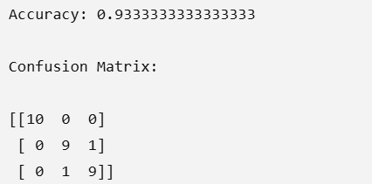

Classsification Report:

precision recall f1-score support

setosa 1.00 1.00 1.00 10
versicolor 0.90 0.90 0.90 10
virginica 0.90 0.90 0.90 10

accuracy 0.93 30
macro avg 0.93 0.93 0.93 30
weighted avg 0.93 0.93 0.93 30

Two Misclassified Instances:
Instance 1:

Actual: virginica
Predicted: versicolor
Features: [6.1 2.6 5.6 1.4]

Instance 2:

Actual: versicolor
Predicted: virginica
Features: [6.7 3.0 5.0 1.7]

Performance Comment:
The Decision Tree achieved approximately 93.33% accuracy, which indicates good classification performance. Setosa was classified perfectly, while a small number of Versicolor and Virginica samples were confused with each other.

Result:
Thus, the Decision Tree classifier was successfully implemented on the Iris dataset and achieved 93.33% accuracy.

EXPERIMENT 2: REINFORCEMENT LEARNING – Q-LEARNING:

Objective:
To implement Q-Learning for a 4×4 Grid World and obtain the learned optimal policy.

(a) Define Environment and Q-Table:

Aim:
To define the Grid World environment, actions, rewards, Q-table and learning parameters.

Environment:
Grid Size: 4 × 4

Start : (0,0)
Goal : (3,3)
Obstacle: (1,1)

Actions:
0 → Up
1 → Down
2 → Left
3 → Right

Rewards:
Goal → +10
Each step → -1
Obstacle → -5

Hyperparameters:
Learning rate (α) = 0.1
Discount factor (γ) = 0.9
Exploration rate (ε) = 0.2

Program:
import numpy as np
import random

# Grid size
SIZE = 4

# States
start = (0, 0)
goal = (3, 3)
obstacle = (1, 1)

# Actions: Up, Down, Left, Right
actions = [(-1, 0), (1, 0), (0, -1), (0, 1)]
action_names = ['U', 'D', 'L', 'R']

# Hyperparameters
alpha = 0.1
gamma = 0.9
epsilon = 0.2

# Q-table initialized with zeros
Q = np.zeros((SIZE, SIZE, 4))

print("Q-table initialized with zeros:")
print(Q)

(b) Run Q-Learning:

Aim:
To train the agent for 100 episodes and observe the changes in Q-values.

Program:
import numpy as np
import random

SIZE = 4
start = (0, 0)
goal = (3, 3)
obstacle = (1, 1)

actions = [(-1, 0), (1, 0), (0, -1), (0, 1)]
action_names = ['U', 'D', 'L', 'R']

alpha = 0.1
gamma = 0.9
epsilon = 0.2

Q = np.zeros((SIZE, SIZE, 4))

random.seed(42)
np.random.seed(42)

rewards = []
records = {}

for episode in range(1, 101):

state = start
total_reward = 0

for step in range(100):

# Choose action
if random.random() < epsilon:
action = random.randint(0, 3)
else:
action = np.argmax(Q[state[0], state[1]])

# Calculate next state
next_state = (
max(0, min(3, state[0] + actions[action][0])),
max(0, min(3, state[1] + actions[action][1]))
)

# Reward
if next_state == goal:
reward = 10
done = True

elif next_state == obstacle:
reward = -5
next_state = state
done = False

else:
reward = -1
done = False

# Q-learning update
Q[state[0], state[1], action] += alpha * (
reward +
gamma * (0 if done else np.max(Q[next_state[0], next_state[1]]))
- Q[state[0], state[1], action]
)

total_reward += reward
state = next_state

if done:
break

rewards.append(total_reward)

# Record Q-values at selected episodes
if episode in [1, 50, 100]:
records[episode] = (
Q[0, 0].copy(),
Q[2, 2].copy()
)

print("Q-values for representative states:")
for episode in records:
print("\nEpisode", episode)
print("State (0,0):", records[episode][0])
print("State (2,2):", records[episode][1])
Q-Table Evolution
For representative state (0,0):

Episode | Up | Down | Left | Right
1 | -0.199 | -0.199 | -0.199 | -0.199
50 | -2.279 | -2.287 | -2.405 | -2.284
100 | -2.265 | -2.327 | -2.405 | 0.755

For representative state (2,2):
Episode | Up | Down | Left | Right
1 | -0.199 | -0.190 | -0.100 | -0.100
50 | -0.369 | 0.280 | -0.208 | 5.667
100 | -0.279 | 0.280 | -0.208 | 7.171

Observation:
Initially, the Q-values are almost zero because the agent has no knowledge of the environment. As training progresses, actions leading toward the goal receive higher Q-values. Therefore, the Q-table gradually learns the best path.

(c) Final Learned Policy and Cumulative Reward:

Aim:
To extract the final policy and plot the cumulative reward for each episode.

Program:
import matplotlib.pyplot as plt

# Display final policy
print("Final Learned Policy:\n")

for i in range(SIZE):
row = []

for j in range(SIZE):

if (i, j) == goal:
row.append("G")

elif (i, j) == obstacle:
row.append("X")

else:
best_action = np.argmax(Q[i, j])
row.append(action_names[best_action])

print(row)

# Plot cumulative reward
plt.plot(rewards)
plt.xlabel("Episode")
plt.ylabel("Cumulative Reward")
plt.title("Q-Learning Reward per Episode")
plt.grid()
plt.show()

Example Final Policy
The policy is displayed using:
U = Up
D = Down
L = Left
R = Right
X = Obstacle
G = Goal

A learned policy will generally direct the agent toward the goal while avoiding the obstacle.
One possible optimal path is:

Start → Right → Right → Right
↓
Down → Down → Down → Goal

Convergence Behaviour:
During the early episodes, the agent explores different actions, so the rewards are generally low. As training continues, the Q-values for useful actions increase and the agent increasingly selects actions that lead toward the goal.
The reward curve therefore tends to improve and stabilize, showing that the Q-learning agent is learning a useful policy.

Result:
Thus, the Q-Learning algorithm was successfully implemented for a 4×4 Grid World, and the agent learned a policy that moves toward the goal while considering the obstacle and rewards.

